SMART SAFETY SUPERSTORE
E N T E R P R I S E G R O U P

e-MAIL: smartsafetysuperstore-enterprisegroup@outlook.com

“FOR GOD SO LOVED THE WORLD THAT HE GAVE HIS ONLY BEGOTTEN SON, THAT WHOEVER BELIEVES IN HIM SHOULD NOT PERISH BUT HAVE EVERLASTING LIFE”. JOHN 3:16

CHANNELIZER CONES |  |  | Meets NCHRP-350 and MUTCD Standards.
MODEL  NO. | HEIGHT | DESCRIPTION | PRICE EACH
 |  |  | 1 | 3+
SSCC-H-2845 | 42" | Standard Cone w/ 10 lb. Base | $41 | $39
SRCC-H-2846 |  | Reflective Cone w/ 10 lb. Base | $63 | $61

BULK BUY – SAVE UP TO 39% |  |  | Sold in Multiples of 6
MODEL  NO. | HEIGHT | DESCRIPTION | PRICE EACH (MIN. 6)
 |  |  | 6 | 24+
SSC-H-3417 | 42" | Standard Cone w/o Base | $18 | $17
SRC-H-3418 |  | Reflective Cone w/o Base | $29 | $27
SSB-H-3416 | N/A | 10 lb. Square Base | $12 | $11
SHB-H-5492 | N/A | 16 lb. Hexagonal Base | $20 | $19
Meets NCHRP-350 and MUTCD Standards.

CHANNELIZER CONES & ACCESSORIES
Stackable. Use less space than barricades for road construction.
- Large, loop-top carry handle.
- Impact resistant, low-density polyethylene.
- Detachable rubber base.
- Reflective – 6" high-intensity bands for visibility.

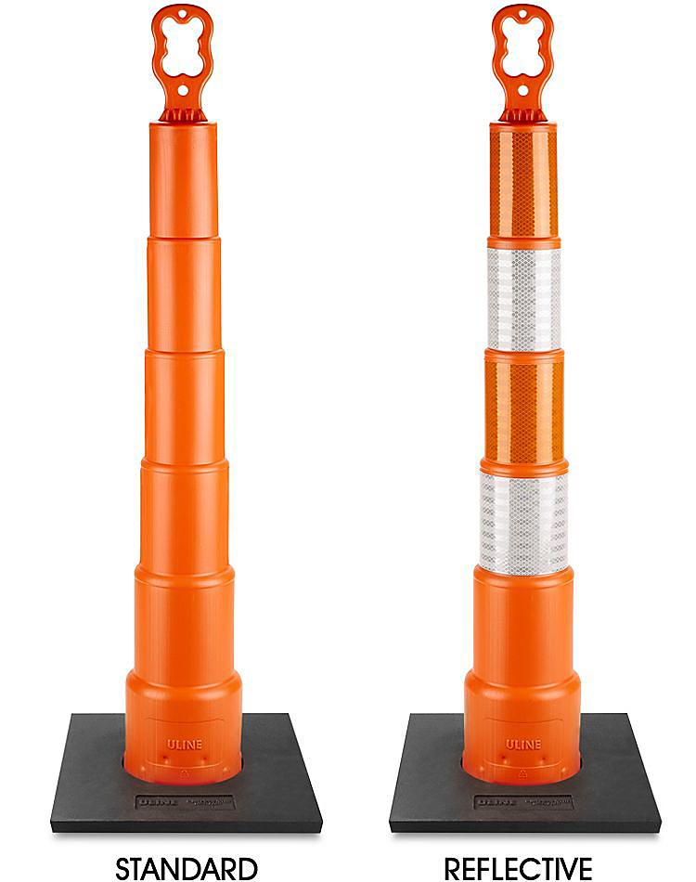

CHANNELIZER CONE ACCESSORIES

MODEL  NO. | DESCRIPTION | PRICE EACH (MIN. 6)
 |  | 6 | 24+
SSB-H-3416 | 10 lb. Square Base | $12 | $11
Sold in Multiples of 6
Meets NCHRP-350 and MUTCD Standards

10 lb Square Rubber Base for Channelizer Cone
Sturdy base stabilizes channelizer cone.
- Stable in all types of weather.
- For use with Standard and Reflective Cones

Sold in Multiples of 6
MODEL  NO. | DESCRIPTION | PRICE EACH (MIN. 6)
 |  | 6 | 24+
SHB-H-5492 | 16 lb. Hexagonal Base | $20 | $19

Meets NCHRP-350 and MUTCD Standards

16 lb Hexagonal Rubber Base for Channelizer Cone
Sturdy base stabilizes channelizer cone.
- Stable in all types of weather.
- For use with Standard and Reflective Cones

10 lb Square Rubber Base for Channelizer Cone

16 lb Hexagonal Rubber Base for Channelizer Cone

