SMART SAFETY SUPERSTORE
E N T E R P R I S E G R O U P

e-MAIL: smartsafetysuperstore-enterprisegroup@outlook.com

“FOR GOD SO LOVED THE WORLD THAT HE GAVE HIS ONLY BEGOTTEN SON, THAT WHOEVER BELIEVES IN HIM SHOULD NOT PERISH BUT HAVE EVERLASTING LIFE”. JOHN 3:16

REFLECTIVE TRAFFIC CONES |  |  | Lime or Orange
MODEL  NO. | HEIGHT | WT.  (LBS.) | PRICE EACH (MIN. 2)
 |  |  | 2 | 10 | 25 | 50+
SR18-14709 | 18" | 3 | $19 | $18 | $17 | $16
SR28-12188 | 28" | 7 | $30 | $25 each any quantity
SR36-14710 | 36" | 10 | $33 | $32 | $30 | $28
STANDARD TRAFFIC CONES |  |  | Lime or Orange
MODEL  NO. | HEIGHT | WT.  (LBS.) | PRICE EACH (MIN. 2)
 |  |  | 2 | 10 | 25 | 50+
SS6-19289 | 6" | 1 | $8 | $7 | $6 | $5
SS12-13529 | 12" | 2 | $10 | $9 | $8 | $7
SS18-7877 | 18" | 3 | $11 | $8 each any quantity
SS28-7879 | 28" | 7 | $17 | $16 | $15 | $14
SS36- 14708 | 36" | 10 | $24 | $23 | $21 | $19
HEAVY DUTY TRAFFIC CONES |  |  | Lime or Orange
MODEL  NO. | HEIGHT | WT.  (LBS.) | PRICE EACH (MIN. 2)
 |  |  | 2 | 10 | 25 | 50+
SH18-21633 | 18" | 3 | $ 22 | $21 | $20 | $19
SH28-21634* | 28" | 10 | $ 33 | $32 | $30 | $28
SH36-21635* | 36" | 12 | $ 36 | $31 each any quantity
 |  |  | * Meets MUTCD Nighttime Requirements

Standard Traffic Cones - Reroute traffic as needed. Use indoors or outdoors.
- Durable PVC. Superior stability.
- Stackable.
Reflective Traffic Cones - 3M reflective collars alert drivers in low light conditions.
- Meets MUTCD nighttime requirements.
Heavy Duty Traffic Cones - From Alaska to the Great Plains, stays put in the windiest weather.
- 3M reflective collars won't peel off.
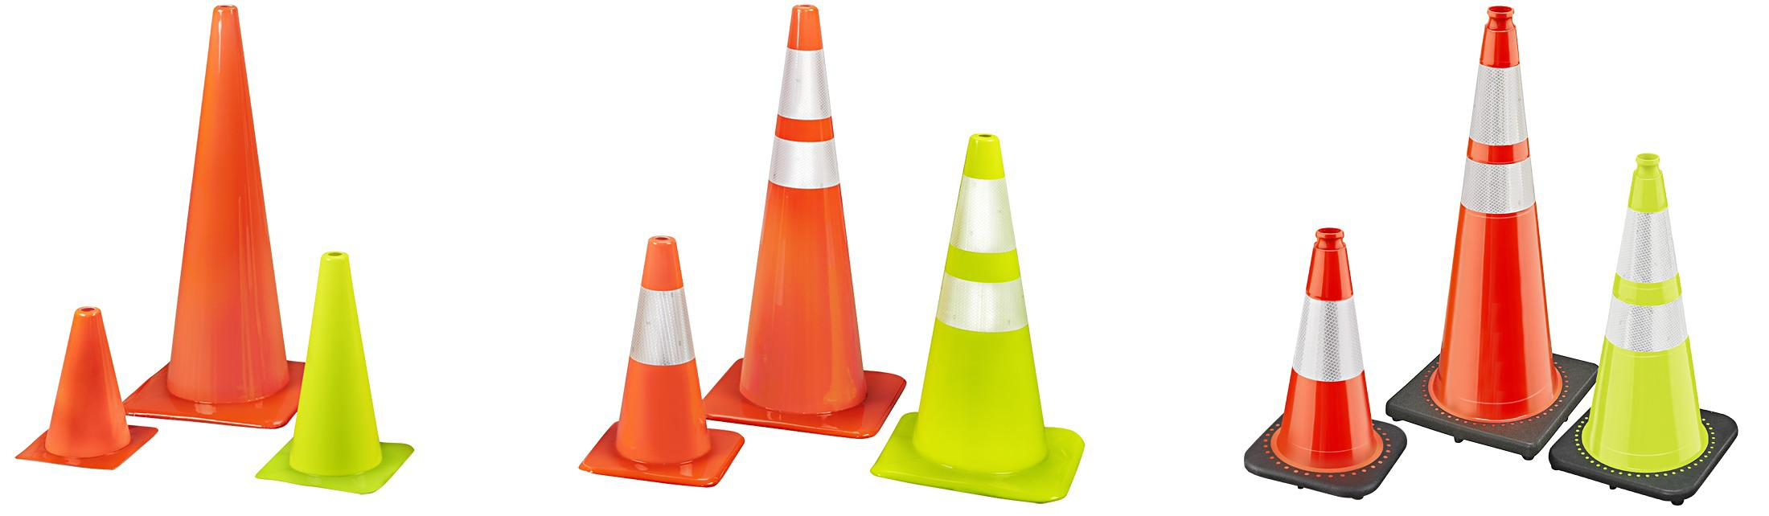

TRAFFIC CONES & ACCESSORIES

CONE TOPPER BARRIER |  |  |  | * Lime or Orange
MODEL  NO. |  | DESCRIPTION | EXPANDABLE  RANGE | PRICE EACH (MIN. 2)
 |  |  |  | 2 | 4+
SCTB-S-21636 |  | Traffic Cone Belt | 10 ft. | $47 | $45
 |  |  |  | 2 | 10+
SHDTC-S-21635 * |  | 36" Heavy Duty Traffic Cone |  | 36 | 31

TRAFFIC CONE VEHICLE BRACKET
MODEL  NO. | DESCRIPTION | HEIGHT | WT.  (LBS.) | PRICE EACH
 |  |  |  | 1 | 4+
STCVB-H-8177 | Traffic Cone Bracket | 22" | 2 | $24 | $22

TRAFFIC CONE WEIGHT
MODEL  NO. | DESCRIPTION | INSIDE  DIAMETER | WT.  (LBS.) | PRICE EACH (MIN. 2)
 |  |  |  | 2 | 10+
STCW-H-9481 | Traffic Cone Weight | 10 3/4" | 7 | $12 | $11

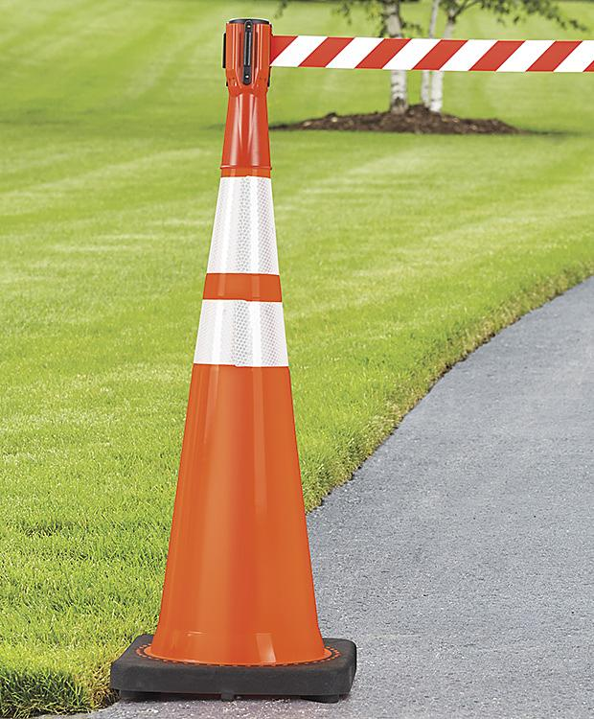
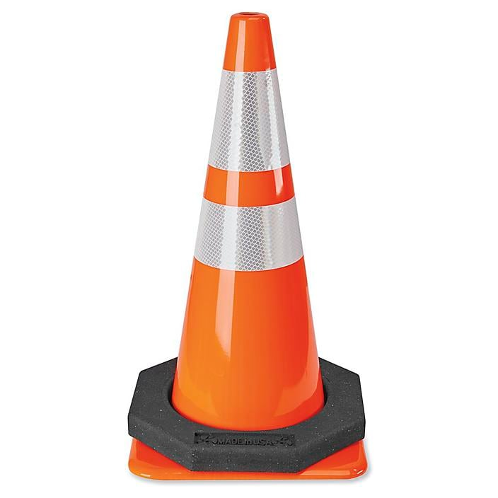
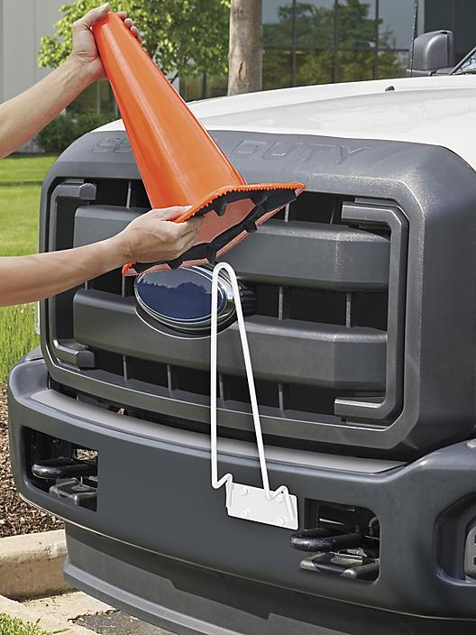
TRAFFIC CONE WEIGHT
VEHICLE BRACKET
CONE TOPPER

